Working with TestNG - IntelliJ IDE

Adding TestNG to IntelliJ IDE

Download and save this Jar files (Save every jar in its own folder)

* TestNG 7.0.0.jar
* commander-7.0.0-2.jar
* jcommander-1.48.jar

Add the jars to your project.

Add the Create TestNG XML plugin by:

[File]-> [Settings name] ->[Plugins]-> Install Create TestNG XML

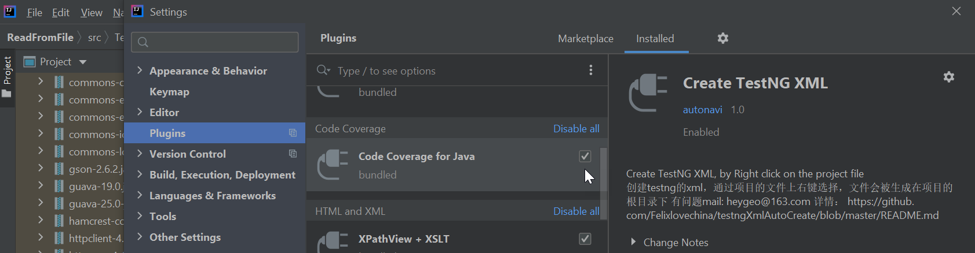

After the installation of the plugin restart the IDE -> open the IDE again Park on the project level and check that you have a menu entry "Crate TestNG XML".

Create TestNG xml file

Click the menu entry "[Crate TestNG XML]" -> message with the location on the file will appear OK the message.

[File]-> [Reload all from disk]-> the new XML file exist on the project structure.

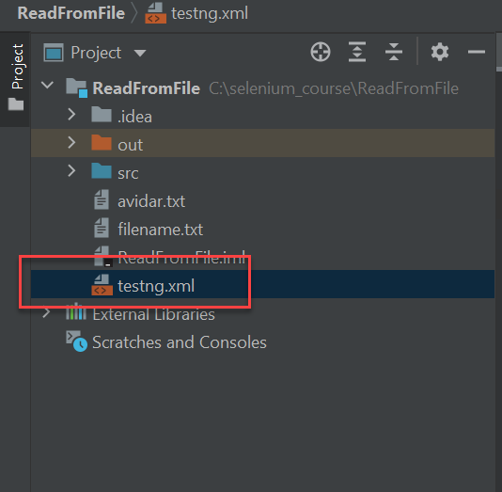

Click the XML file-> the file will open on the right side.

To reformat the file: go to [Code]-> [Reformat code]-> the file showing in XML format.

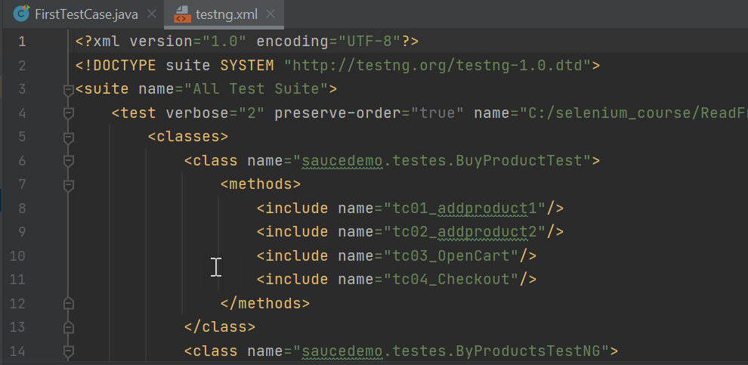

After you run TestNG XML, you can see the report

Configure TestNG reports

From the menu [Run]-> [Edit configuration]

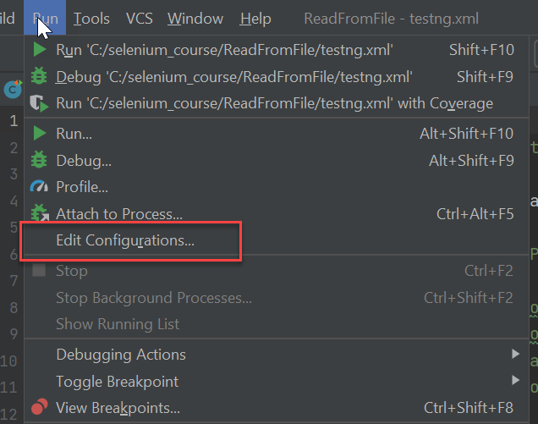

Using the + sing add the above 2 entries -> [Apply]-> [OK]

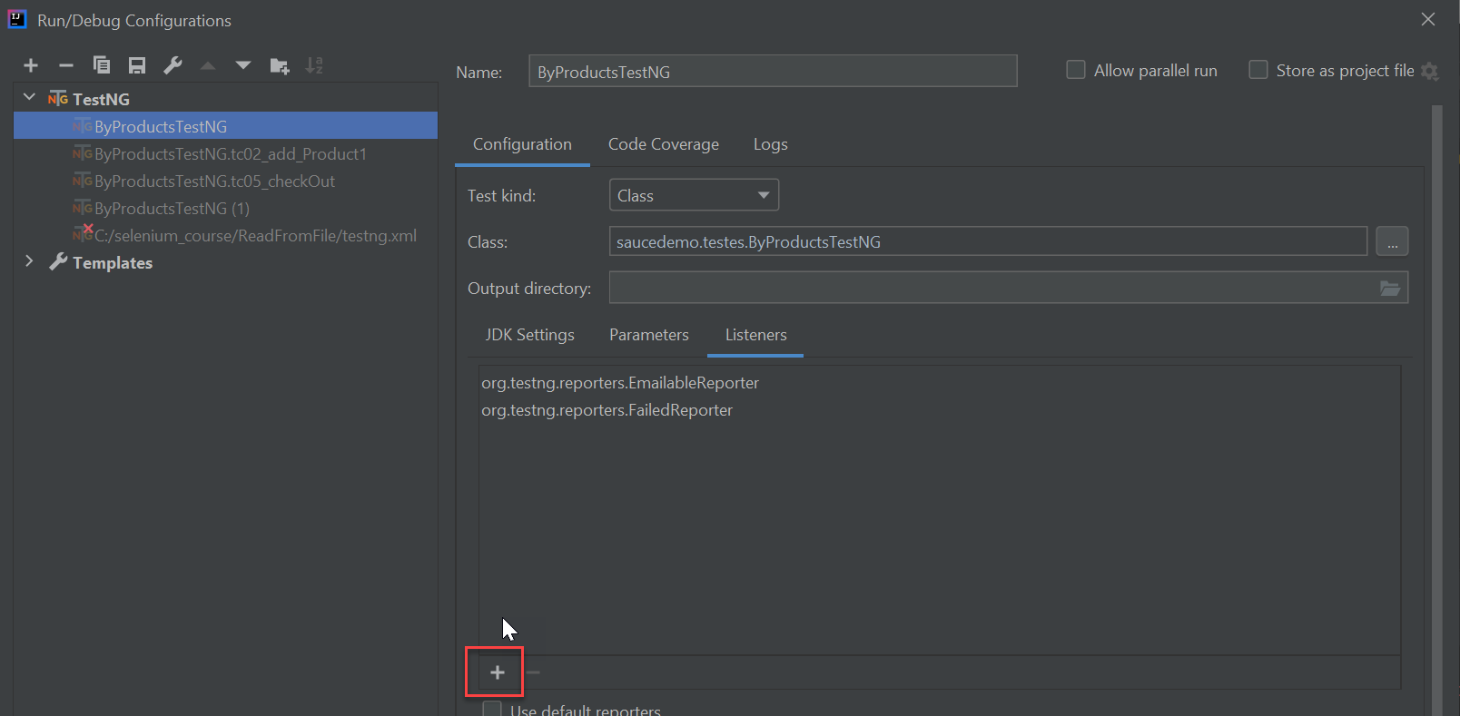

Re run the TestNG xml file

New folder name Test-output new exist in your project structure

